Darshana pubudu keerthirathna

ICM 106 OR23106564

PROGRAMMING FUNDAMENTALS WEEK – 07 ASSIGNMENT

**Question 01**

**i)**

import java.util.*;

class Example {

public static void main(String args[]) {

int[] arr = {12,35,47,59,62,73,81,93,111,121}

}

}

**ii)**

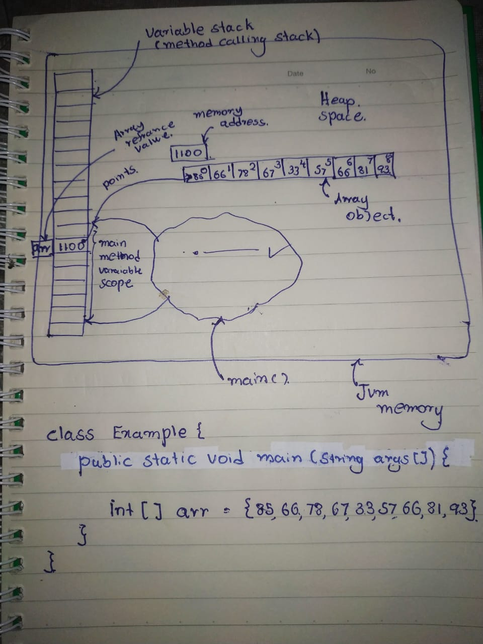

**iii)**

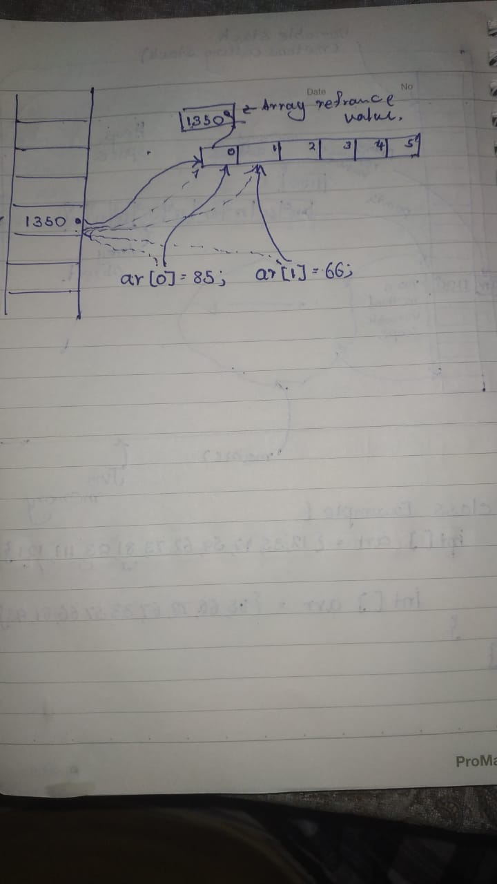

**iv)**

import java.util.*;

class Example {

public static void main(String args[]) {

int[] arr = {12,35,47,59,62,73,81,93,111,121};

System.out.println(arr[0]);

System.out.println(arr[3]);

System.out.println(arr[5]);

}

}

Prints

12

59

63

**Question 02**

import java.util.*;

class Example {

public static void main(String args[]) {

//Create Array and input given Data

double[] avgMarks = {85.66,78.00,67.33,57.66,81,91,53.66,61.66,74.33,79.33};

for (int i = 0; i < avgMarks.length; i++){

if (i==2 || i==6){

System.out.println((i+1)+(i==2?"rd ":"th ")+"Student Avarage :"+avgMarks[i]);

}

}

}

}

**Question 03**

import java.util.*;

class Example {

public static void main(String args[]) {

//Enter Data using single Statement

long[] reserves = {2362,2311,1917,1912,1887,1854,1717,1717,1779,1705,1806,1896};

//Print array using foreach method

for(long a : reserves){

System.out.println(a*1000000);

//Correct Incorrect Data

reserves[3] = 1812;

reserves[6] = 1817;

}

//Print Corrected Data

System.out.println();

for (int i = 0; i < reserves.length; i++){

if(i==3 ||i==6){

System.out.println((i==3?"April":"July")+" - "+reserves[i]);

}

}

}

}

**Question 04**

import java.util.*;

class Example {

public static void main(String args[]) {

//Institute Of Computer Engineering Technology

//Enter Data using single Statement

char[] word = {73,110,115,116,105,116,117,116,101,32,79,102,32,67,111,109,112,117,116,101,114,32,69,110,103,105,110,101,101,114,105,110,103,32,84,101,99,104,110,111,108,111,103,121};

//Print array using foreach method

for(char a : word){

System.out.print(a==32?"\n":a);

}

}

}

**Question 05**